Supplementary Information of
Quantification of HAXPES: Calculating Relative Sensitivity Factors for 1.5 keV - 10 keV Photons and any Instrument Geometry
By David J H Cant*, Ben F Spencer, Wendy R Flavell and Alexander G Shard

Plots of asymmetry parameters and modelled data for selected peaks
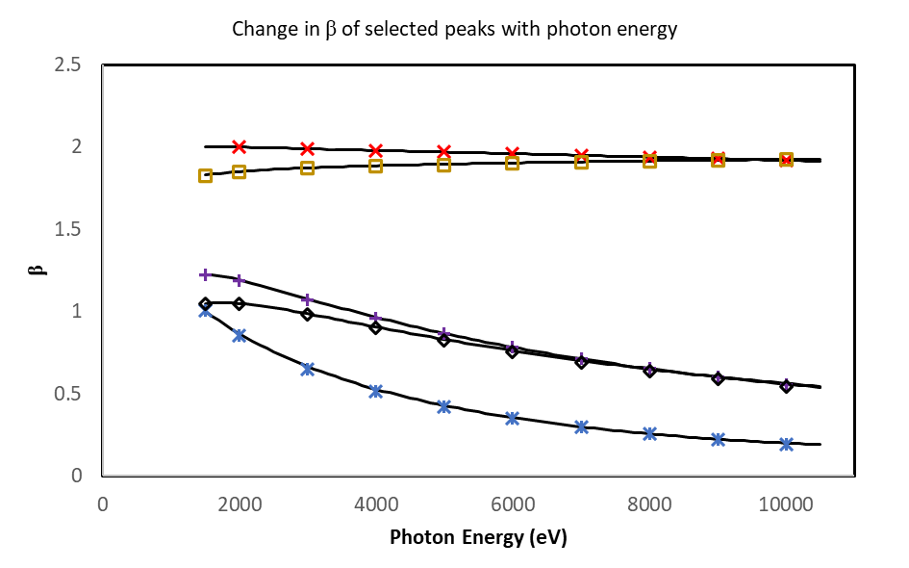
Figure S1 - β values from Trzhaskovskaya and Yarzhemsky[1], [2] for selected subshells. Values from the database are shown as points, the descriptive curves in this paper are shown as lines. β values for s shells are typically very close to 2, so only the Si 1s and Au 4s are shown as examples. Markers correspond to subshells as follows: ( - Si 1s); ( - Si 2p ³/₂); ( - Ag 3d ⁵/₂); ( - Au 4s); ( - Au 4f ⁷/₂).

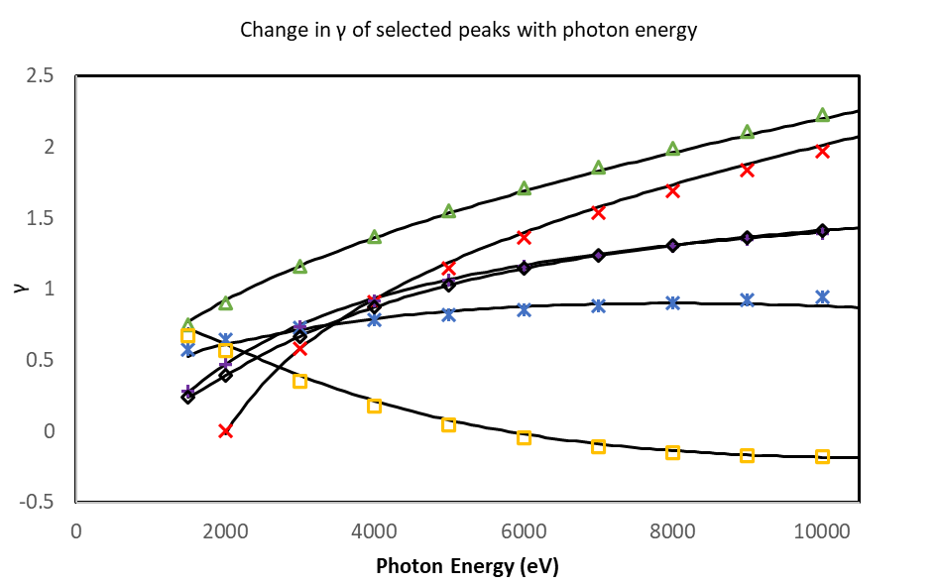
Figure S2 - γ values from Trzhaskovskaya and Yarzhemsky[1], [2] for selected subshells. Values from the database are shown as points, the descriptive curves in this paper are shown as lines. Markers correspond to subshells as follows: ( - C 1s); ( - Si 1s); ( - Si 2p ³/₂); ( - Ag 3d ⁵/₂); ( - Au 4s); ( - Au 4f ⁷/₂).

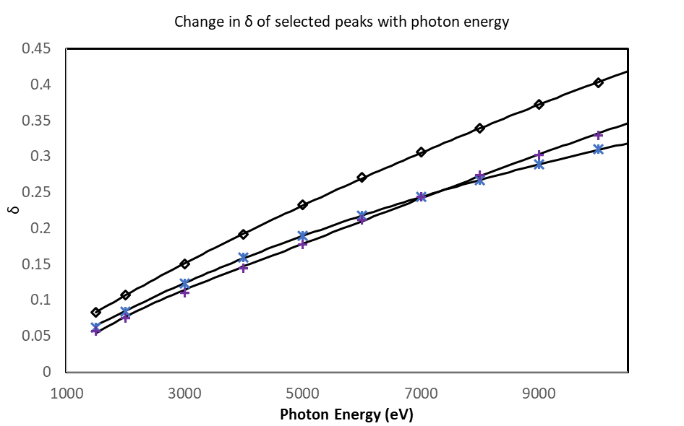
Figure S3 - δ values from Trzhaskovskaya and Yarzhemsky[1], [2] for selected subshells. Values from the database are shown as points, the descriptive curves in this paper are shown as lines. Markers correspond to subshells as follows: ( - Si 2p ³/₂); ( - Ag 3d ⁵/₂); ( - Au 4f ⁷/₂).

Plots of model deviation from database values for asymmetry parameters
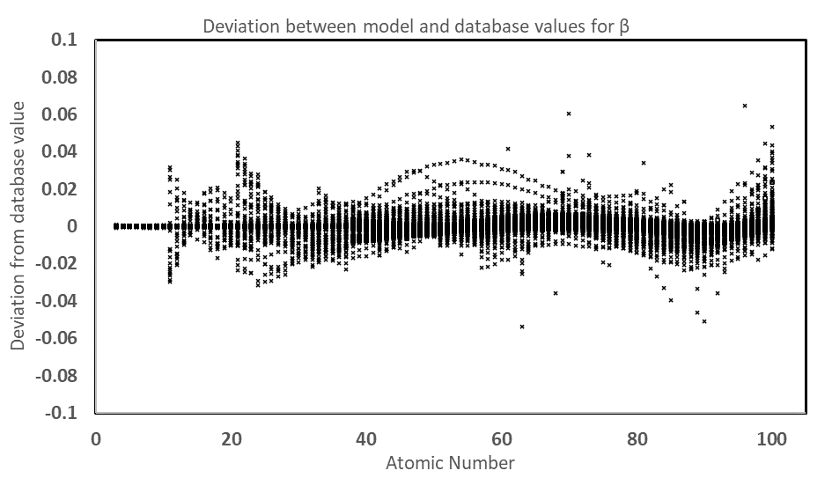
Figure S4 - Plot of the deviation between modelled values of β and database values.
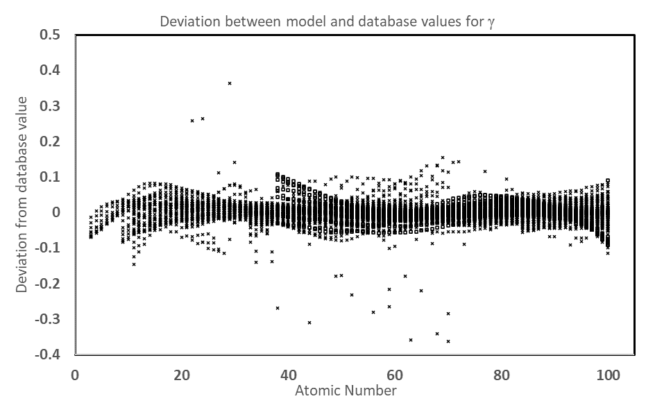
Figure S5 - Plot of the deviation between modelled values of γ and database values.
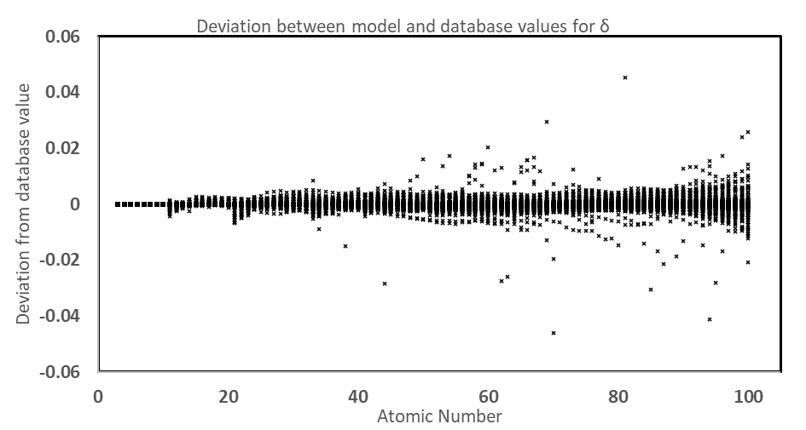
Figure S6 - Plot of the deviation between modelled values of δ and database values.

References
[1] M. B. Trzhaskovskaya and V. G. Yarzhemsky, “Dirac–Fock photoionization parameters for HAXPES applications,” At. Data Nucl. Data Tables, vol. 119, pp. 99–174, Jan. 2018, doi: 10.1016/J.ADT.2017.04.003.
[2] M. B. Trzhaskovskaya and V. G. Yarzhemsky, “Dirac–Fock photoionization parameters for HAXPES applications, Part II: Inner atomic shells,” At. Data Nucl. Data Tables, vol. 129–130, p. 101280, Sep. 2019, doi: 10.1016/J.ADT.2019.05.001.

